786
Name: Muhammad Sherjeel Akhtar
Roll No: 20p-0101
Subject: Numerical Computing
Assignment No: 03
Submitted To Respect Sir: Muhammad Nauman
Section: 5A

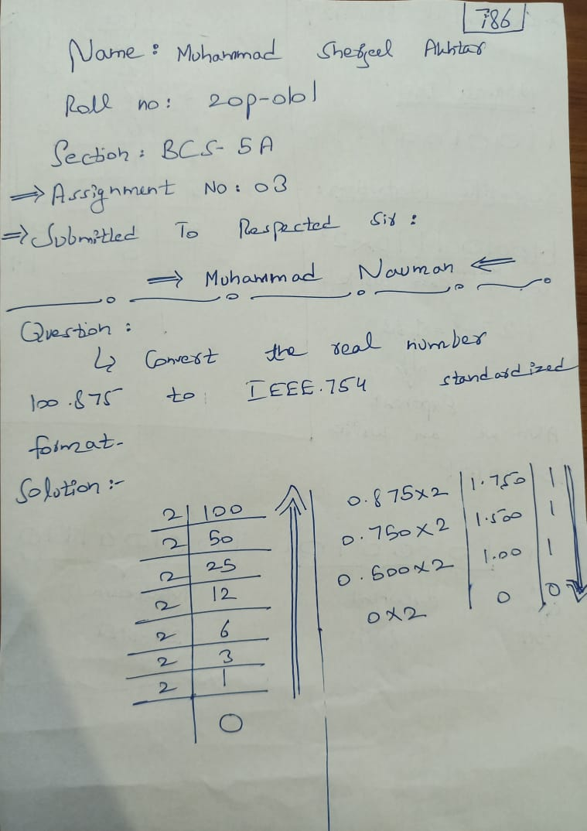
.

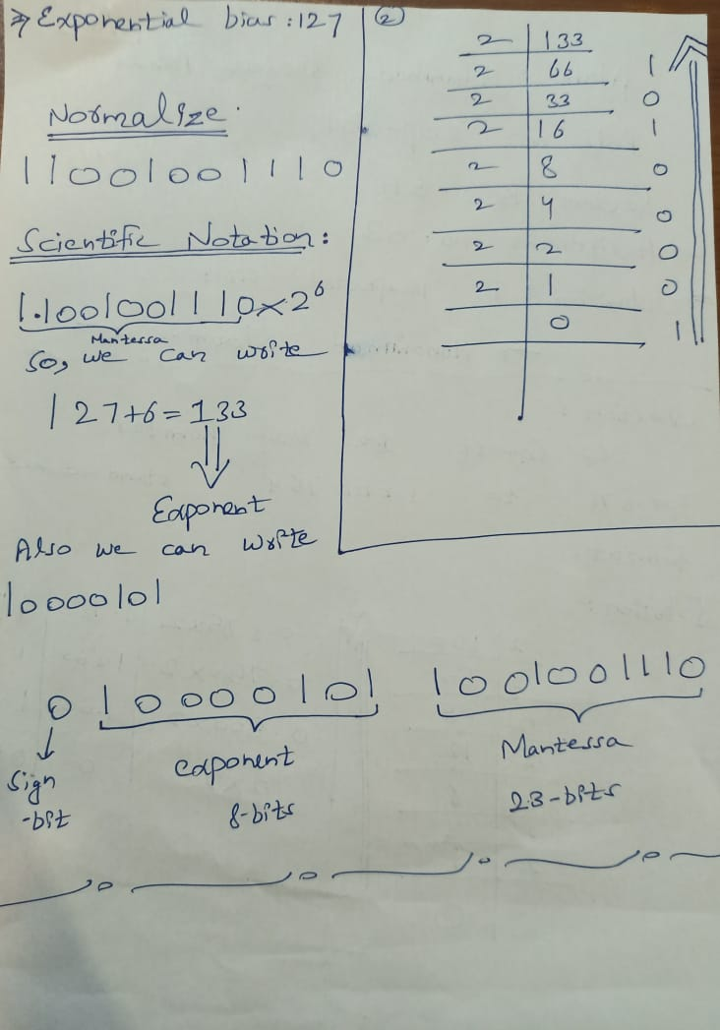

END.

